Know which vessel is the giveway vessel and the action to be taken by giveway vessel in the following situations:-
In all cases rembember, there is no such thing as a right of way. There is a stand-on vessel which should, if practicable, maintain course and speed, and the give way vessal which should;
Do what prudence says is propper,
Port or Starbaord, Slow or Stop her.

But remember the first principle is the avoidance of colision. If you are in the stand on vessel and it looks like the giveway vesseal is not taking (adequate) action, you should take your own evasive action. This should be done so that it will not conflict with what would be the best course of action for the give way vessel.
These are the International Regulations for the Prevention of Collisions at Sea, not the Sutton Dinght Club sail-racing rules.

A risk of collision exists where the relative bearing from you to the other vessel does not change significantly.

Two power driven vessels head on
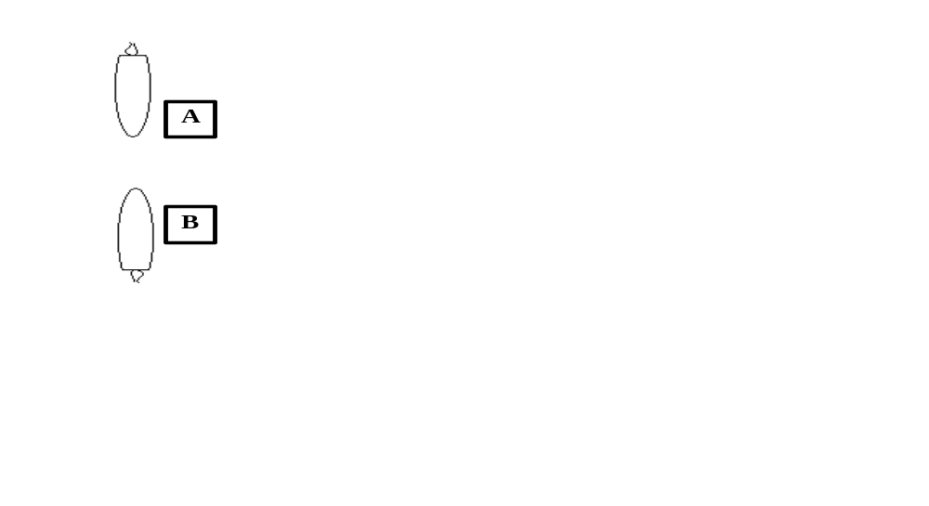

Both vessels turn to starbaord in order to pass port to port.

Two power driven vessels crossing
If to starbaord red appear,
Tis your duty to keep clear

Two power driven vessels one overtaking the other
Overtaking vessel keeps clear. A vessel is defined as Overtaking if it is within 22½ degrees abaft the beam on eithe side. This si the arc of visibility of the strn light at night.

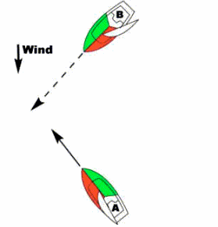
Two sailing vessels crossing wind on same side
Windward vessel keeps clear. (The one closest to where the wind is coming from) The windward vessel has more options as to what evasive action to take.

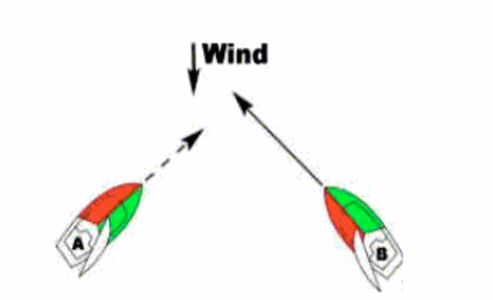Two sailing vessels crossing wind on opposite side

Starbaord tack stands on, Port tack gives way.

Sailing vessel overtaking power driven vessel
Overtaking vessel keeps clear

Sailing vessel and power driven vessel crossing
Generally the sailing vessel stands on, the power vessel gives way. If the power vessel is in a marked channel, constrained by draught, engaged in fishing or underwater opperations, towing, not0under-command or otherwise restricted in the ability to manouver, the sailing vessel should give way.

Symbol for sailing vessel proceeding under sail and power.
A sailing vessel proceding under sail and power shall show an inverted cone (a.k.a upsidedown triangle) in the fore-rigging where it will best be seen.
The assumption can be made that all situations given involve risk of collision

Understand the conduct of vessels navigating in a narrow channel and when crossing a fairway
Narrow channels and fairways should be crossed as near as possible at right angles and as quickly as possible. If navigating in the direction of a channel smaller vessels must not impeed bigger vessels. If possible keep just outside the channel. Keep to the right so as to pass port to port.

STEERING LIGHTS
Lights shown by a sailing vessel underway

Under 7m; capable of showing a white light
Under 20m; A ‘tricolour’ masthead light showing red, white and green over the prescribed arcs.
Over 20m; must show seperate port, starboard and stern lights.
Any sailing vessel may, in addition to seperate side and sternlights, show an all-round red light over an allround green light near the top of the mast.

Lights shown by a power driven vessel underway

Side and stern lights plus
Mast head light with the same arc of visibility as the side lights
A second masthead light with the same arc of visibility, with the after light higher than the forward light. (This second light is optional in vessels under 50m)
Vessels under 7m AND under 7kts may show a single allround white light
Vessels under 12m (no speed condition) may show an all round white light and side lights.

Lights to be shown by a vessel under oars
May show lights as for sail but must be capable of showing a white light. This minimum is in fact what usually happens.

Know the arc of visibility of the following lights:-
- Side lights
From dead ahead to 22½ degrees abaft the beam. The port light shall be red. The starboard light shall be green.

- Stern lights
From 22½ degrees abaft the beam on one side through dead astern to 22½ degress on the othe side
- Masthead lights
Masthead lights are visible over the combined arc of BOTH sidelights
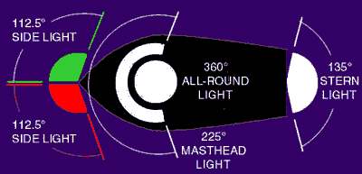

Note that this is an extremely simplified guide to the regulations. The International Regulations for the Prevention of Colisions at Sea are extremely detailed (what exactly is “green”). This much knowledge and a heavy dose of common sense (just get out of the way of much bigger boats) should be adequate for most scouters in most situations.

